Supplementary information

Assessing Energy Security Risks to Ireland’s Net-Zero Transition Under Cross-Border Supply Uncertainty

Fatemeh Rostami^{*,a,b,c}, Ankita Singh Gaur^{d,e}, Hannah Daly ^{a,b}, Stephanie T. G. Moura ^{a,b}, Paul Deane ^{a,b}, Vahid Aryanpur ^{a,b}

ªSustainability Institute, University College Cork, Ireland
^{b}School of Engineering and Architecture, University College Cork, Co. Cork, Ireland
^{c}International Institute for Applied Systems Analysis (IIASA), Schlossplatz 1, 2361 Laxenburg, Austria
^{d}Van 't Hoff Institute for Molecular Sciences (HIMS), Science Park 904, University of Amsterdam, 1090 GD Amsterdam
^{e}Energy and Materials Transition (EMT), TNO, Amsterdam, the Netherlands

*Corresponding author email: FRostami@ucc.ie

Table of Contents
Section A: Methodology 2
1.1. Timing scenarios 2
1.2. Uncertainty in energy commodity costs 3
1.3. Cost uncertainty in renewable energy technologies 4
1.4. Supply chain disruptions in energy commodities 5
1.5. Constraints on renewable energy capacity expansion 6
Section B: Further results 8
Section C: References 9

Section A: Methodology
In this section, we discuss methodological details of assessing uncertainty scenarios for each of the risk categories considered in this contribution.

1.1. Timing scenarios
In this study the 2026-2050 is divided into five five-year subperiods. Timing scenarios are generated using a random selection function implemented in Python, from these subperiods and assembling them into representative configurations for different spike frequencies, presented in Table S1. Each row in this table represents a scenario and we end up with 25 timing scenarios.

Table S1. Generated timing scenarios
Shock frequency | Occurrence year(s)
1 | 2026
1 | 2031
1 | 2038
1 | 2042
1 | 2047
2 | 2029, 2037
2 | 2030, 2047
2 | 2031, 2036
2 | 2035, 2041
2 | 2042, 2050
3 | 2037, 2039, 2041
3 | 2026, 2031, 2042
3 | 2034, 2048, 2050
3 | 2029, 2044, 2049
3 | 2027, 2035, 2038
4 | 2026, 2030, 2036, 2044
4 | 2035, 2038, 2045, 2048
4 | 2031, 2041, 2047, 2049
4 | 2029, 2034, 2039, 2046
4 | 2027, 2032, 2037, 2042
5 | 2026, 2028, 2034, 2041, 2043
5 | 2029, 2031, 2036, 2046, 2048
5 | 2030, 2037, 2045, 2047, 2050
5 | 2032, 2035, 2039, 2042, 2044
5 | 2027, 2033, 2038, 2040, 2049

1.2. Uncertainty in energy commodity costs
To capture uncertainty in the magnitude of energy commodities future cost variations, Monte Carlo simulation is applied to generate a large set of plausible cost trajectories for key energy commodities in Ireland, including biomass, natural gas, oil, and imported electricity. This approach propagates historical variability through the energy system model, allowing a probabilistic assessment of potential future prices instead of relying on a single deterministic forecast.
Historical Irish energy commodity prices (2008–2025) were obtained for biomass, natural gas, and oil from the Sustainable Energy Authority of Ireland (SEAI) [1], while wholesale electricity prices are used as a proxy for imported electricity costs considering that Ireland operates within an integrated wholesale electricity market [2]. These data capture major market disturbances, including the COVID-19 pandemic and the energy crisis following Russia’s invasion of Ukraine, which led to significantly larger price increases for conventional fuels compared to the more recent US–Israel–Iran conflict [1], [3]. Data prior to 2008 are excluded due to structural changes in energy markets that reduce their relevance, and the collected data are reported in Supplementary data. Short-term daily or monthly variations are also excluded, as they have minimal impact on long-term system outcomes.
Historical trends indicate that while prices evolve with temporal dependence, extreme price increases are typically followed by partial corrections. Based on this, three price regimes are defined:
- Normal years: moderate fluctuations around historical trends
- Spike years: abrupt positive price increases
- Correction years: partial downward adjustment following spikes

To capture these variations and given that energy commodity prices are strictly positive and exhibit multiplicative fluctuations, we model uncertainty in logarithmic space using annual log-growth rates, as in Eq. 1.

$$g_{t}=\ln\left(\frac{C_{t}}{C_{t-1}}\right) (1)$$
where $C_{t}$ is the commodity cost in year $t$, $C_{t-1}$ is the cost in the previous year, and $g_{t}$ represents the log-growth rate.

Small annual changes within ±2.5% are treated as normal fluctuations, reflecting typical year-to-year variations observed in the historical data and broadly consistent with inflation-driven changes in Ireland [4]. Larger deviations are classified as spike events, while the year immediately following a spike is assigned to the correction regime. For each regime, log-growth rates are modelled using normal distributions:

$$g_{t}∼\left\{\begin{matrix}N(μ_{g},σ_{g}^{2}), & \text{normal year} \\ N(μ_{s},σ_{s}^{2}), & \text{spike year} \\ N(μ_{c},σ_{c}^{2}), & \text{correction year}\end{matrix}\right.$$
Where median ($μ$) and standard deviation ($σ$) are estimated from historical data for each regime.
Starting from the last observed cost (2025), future prices are computed recursively for each scenario s by Eq.2:

$$C_{t}^{\left(s\right)}=C_{t-1}^{\left(s\right)}⋅\exp\left(g_{t}^{\left(s\right)}\right) (2)$$

where $s$ denotes scenario index and the reaming parameters are explained after Eq.1.

From these simulations, the 10th (P10), 50th (P50), and 90th (P90) percentiles are extracted, representing low, median, and high-cost trajectories, respectively. These percentile-based trajectories are used in subsequent analyses.
To avoid unrealistically large price shocks, spike magnitudes are constrained based on historical observations. We observe threefold price increases for natural gas, 2.3-fold for the electricity, 2.6-fold for oil, and 2.2-fold for bulk wood [1]. This ensures that simulated price changes remain within a plausible range.

1.3. Cost uncertainty in renewable energy technologies
Between 2011 and 2022, manufacturing and scale efficiencies reduced some cost components for batteries. However, the share of cathode materials in total battery cost increased significantly, rising from around 2% to nearly 40% [5]. Future battery cost variations are expected to be strongly dependent on price of critical minerals. Table S2 presents the estimated battery pack price response to different increases in lithium, nickel, and graphite prices [6]. For example, a doubling of lithium prices is estimated to increase battery pack costs by approximately 5%.

Table S2. Battery pack price changes by variations in minerals cost* [6].
Cost variations | Lithium |  |  | Nickel |  |  | Graphite
Mineral price increase | 2x | 5x | 10x | 2x | 5x | 10x | 2x | 5x | 10x
Battery price increase [%] | 5 | 21 | 47 | 4 | 17 | 39 | 4 | 17 | 39
*Estimates correspond to a representative lithium-ion battery pack with an average cost of approximately 115 USD/kWh in 2024, of which around 15 USD/kWh is attributed to mineral inputs.

Using the same framework applied for energy commodity price uncertainty (Section 1.2), the 10th (P10), 50th (P50), and 90th (P90) percentiles are generated for lithium, nickel, and graphite using their historical data and Monte Carlo simulation. Compared to energy commodities, mineral price spikes are allowed to reach significantly higher magnitudes (i.e., up to 10 times) due to observed market volatility based on historical data. This approach allows a wide range of mineral price combinations to emerge across scenarios. For instance, in a given year lithium prices may increase eight-fold while nickel and graphite prices rise three-fold and five-fold, respectively. The same concept is used for selecting the spike years and the frequency of spikes.
To collect price of these elements over the last years, we track their price evolution between 2021 and 2025 using the Global Critical Minerals Outlook published by the International Energy Agency [6]. These trends reveal strong multiplicative price fluctuations (see Supplementary data). Because mineral markets have experienced rapid structural changes in response to the accelerating energy transition, earlier historical data are excluded to avoid distortions from outdated market conditions. We then translate the resulting mineral cost trajectories into battery pack cost variations using the response coefficients reported in Table S2. Intermediate values are estimated using linear interpolation between the reported levels.
Finally, battery cost variations are propagated to BEV prices. Consistent with estimates reported by the IEA Global EV Outlook and BloombergNEF, battery packs are assumed to represent approximately 30% of total BEV manufacturing costs [7], [8]. Changes in battery prices are therefore scaled accordingly to estimate the resulting impact on BEV prices, as expressed in Eq. 3.

$$C_{BEV}^{s}=C_{BEV}^{base}∙\left[\left({RCP}_{Li}^{s}+{RCP}_{Ni}^{s}+{RCP}_{c}^{s}\right)∙0.3\right] (3)$$

Here, $C_{\text{BEV}}^{s}$is the BEV cost in scenario $s$, obtained by multiplying the base BEV cost ($C_{\text{BEV}}^{\text{base}}$) by the sum of the mineral response coefficients (from Table S2) scaled by 30% to reflect the battery’s share of total costs. $RCP_{\text{Li}}^{s}$, $RCP_{\text{Ni}}^{s}$, and $RCP_{\text{c}}^{s}$represent the response coefficients of lithium, nickel, and graphite, respectively, under scenario $s$.

Although historical price data for PV panels and wind turbines are available, these costs are influenced by multiple factors, including technological improvements in manufacturing processes, changes in component efficiency and lifetime, and fluctuations in the prices of various raw materials used in their production. Moreover, no empirical datasets currently provide an explicit quantitative link between mineral price fluctuations and the total cost of PV panels or wind turbines. As a result, isolating the direct impact of individual mineral prices on the overall technology cost is challenging.
Therefore, for these two technologies, cost uncertainty is represented using ranges derived from documented trade disruptions affecting renewable energy technologies. Empirical evidence suggest that heightened geopolitical risks effects are equivalent to an increase in global trade costs of approximately 8-14% [9]. In addition, historical policy interventions have demonstrated the potential for even larger cost impacts. For example, in June 2013 the European Union imposed provisional anti-dumping duties on Chinese solar products, initially set at 11.8% and potentially rising to 47.6% if the dispute remained unresolved [5].
Based on these observations, we adopt a conservative cost variation including 8% increase as optimistic estimation, 11.8% as a realistic probability, and 47.6% as pessimistic condition representation to analyse potential price shocks for PV panels and wind turbines. The method used to determine the timing of cost shock years follows the same approach applied to energy commodities (Section 1.2).

1.4. Supply chain disruptions in energy commodities
Long-term empirical evidence based on global trade data from 1985 to 2025 – including major geopolitical events such as the Gulf War, the 11 September attacks, the Iran-Iraq war, Russia’s invasion of Ukraine, and conflicts in the Middle East – indicates that spikes in geopolitical risk can reduce cross-border trade flows by approximately 30-40% [9].
The 2026 Middle East war represents a particularly severe disruption to fossil fuel supply, with up to 20% of global oil trade affected due to the near closure of the Strait of Hormuz, leading to both reduced physical flows and a reconfiguration of global energy trade networks [10]. However, Ireland’s fossil fuel supply is primarily sourced from regional partners, including the North Sea, the United Kingdom, and the United States. As a result, Ireland is less exposed to direct physical shortages and more affected by indirect market responses, particularly price increases.
Given this context, supply disruptions are represented as reductions in fuel availability within the historically observed range of 30-40%, compared with their demand in base scenario. Therefore, a scenario-based sensitivity analysis is adopted using 35% reduction level as an intermediate disruption.
To represent uncertainty in the timing and frequency of disruptions, the same methodology described in Section 1.2 is applied. For each disruption-frequency category, five timing scenarios are combined with the considered disruption levels, resulting in 5 scenarios per disruption-frequency category. Across all five frequency categories, this yields a total of 25 scenarios per energy commodity.

1.5. Constraints on renewable energy capacity expansion
Several minerals play a particularly critical role in the deployment of clean energy technologies. Global Critical Minerals Outlook 2025 by IEA, highlights lithium, nickel, cobalt, manganese, and graphite for BEVs, silicon, silver, gallium, tellurium, and copper for PV panels, and copper and REEs for wind turbines [8]. As Figure S1 presents, BEV deployment also relies on the availability of copper and REEs, while PV panels and wind turbines are further dependent on nickel supply [8].

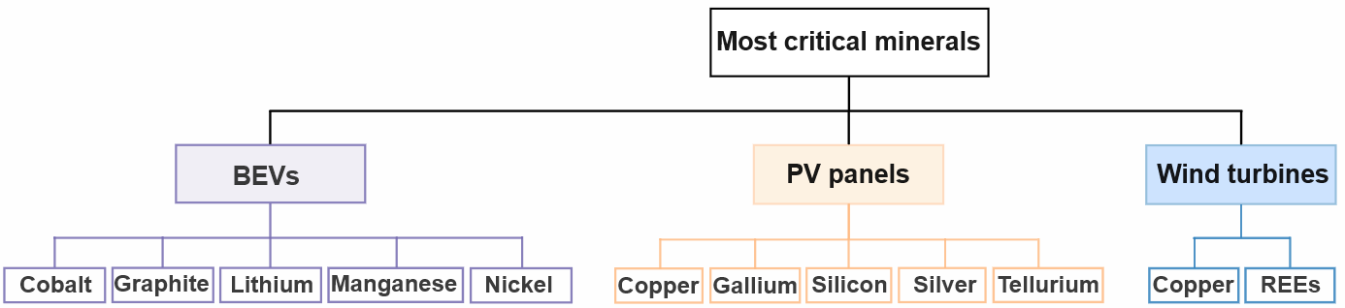
Figure S1. Most critical minerals for each clean energy technology.

In this study, mineral shortages are assumed to translate into proportional constraints on the availability of new clean energy technology capacity. Specifically, if a shortage of a given mineral occurs in year n, the deployment of the corresponding technology in Ireland is proportionally reduced in that year relative to its projected level in the baseline scenario. Although this assumption is a simplification, it provides a consistent and transparent way to quantify the impacts of mineral supply risks and to generate useful insights into their potential system-wide consequences.
Demand projections for these minerals under the Net Zero Scenario are obtained from the IEA Critical Minerals Data Explorer [11], which reports mineral demand up to 2050. Since the IEA data are reported in five-year intervals, linear interpolation is used to estimate annual supply and demand values. Also, supply projections are available for lithium, nickel, cobalt, graphite, copper, and REEs until 2040 [11]. For the remaining minerals (manganese, silicon, silver, gallium, and tellurium), future supply is estimated by applying an annual growth rate of 2.7%, corresponding to the historical average growth rate in global metal mining production [12], to their current production rate. The same growth rate is applied to extend supply projections for minerals with unavailable data beyond 2040 to 2050.
Because these minerals are required by multiple economic sectors, not all the available supply can be allocated to clean energy technologies. To estimate the share of mineral supply available for a given technology, we assume proportional allocation based on demand shares. Specifically, the ratio of technology-specific demand to total mineral demand is used to estimate the portion of each material’s total supply that can be allocated to the desired technology.
Potential shortages are then calculated by comparing the estimated technology-specific supply with the projected demand for that mineral. The shortage ratio is defined as the relative difference between available supply and demand. This calculation is expressed in Eq.4:

$$Shortage_{m,n}^{T}=\frac{\left[S_{m,n}(1+α)^{r}∙Re∙\left(\frac{D_{m,n}^{T}}{D_{m,n}^{Total}}\right)-D_{m,n}^{T}\right]∙100}{D_{m,n}^{T}} (4)$$

where $S_{m,n}$ represents the total supply of mineral $m$ in year $n$ [ton], $D_{m,n}^{T}$denotes the demand for mineral $m$ by technology $T$, and $D_{m,n}^{Total}$ is the total demand for that mineral in the same year. Also, $α$ represents the annual supply growth rate (i.e., $α=2.7\%$) [12], for minerals that their supply projections are not reported. The parameter $r$ represents the number of years elapsed since 2025 (with $r=0$ in 2025 and $r=25$ in 2050). The parameter $Re$represents the recycling factor and is assigned a value of 1.25 for scenarios incorporating the European Commission's target of increasing recycled material supply by 25% [13], and 1.0 for all other scenarios. The resulting shortage ratio represents the potential constraint on the availability of mineral $m$ at year n for technology $T$ development (${Shoertage}_{m,n}^{T}, [\%]$).
To assess the influence of individual minerals on technology deployment, separate scenarios are constructed for each critical mineral. In each scenario, the shortage associated with a given mineral constrains the deployment of the technologies that depend on it. This results in 11 scenarios, allowing the relative importance of different minerals for Ireland’s energy transition to be identified.
In addition to supply-demand imbalances, geopolitical factors may also influence the availability of critical minerals. For example, China imposed export restrictions on gallium and germanium in 2023, highlighting the potential vulnerability of global supply chains [14]. However, Ireland primarily imports finished clean energy technologies rather than raw minerals. As a result, such disruptions are more likely to affect the purchase price of technologies rather than domestic manufacturing capacity.
All the data and calculations available in Supplementary data.

Section B: Further results
Figure S2 illustrates how geopolitical and cross-border risks influence sectoral electrification patterns and electricity demand distribution during Ireland’s net-zero transition.

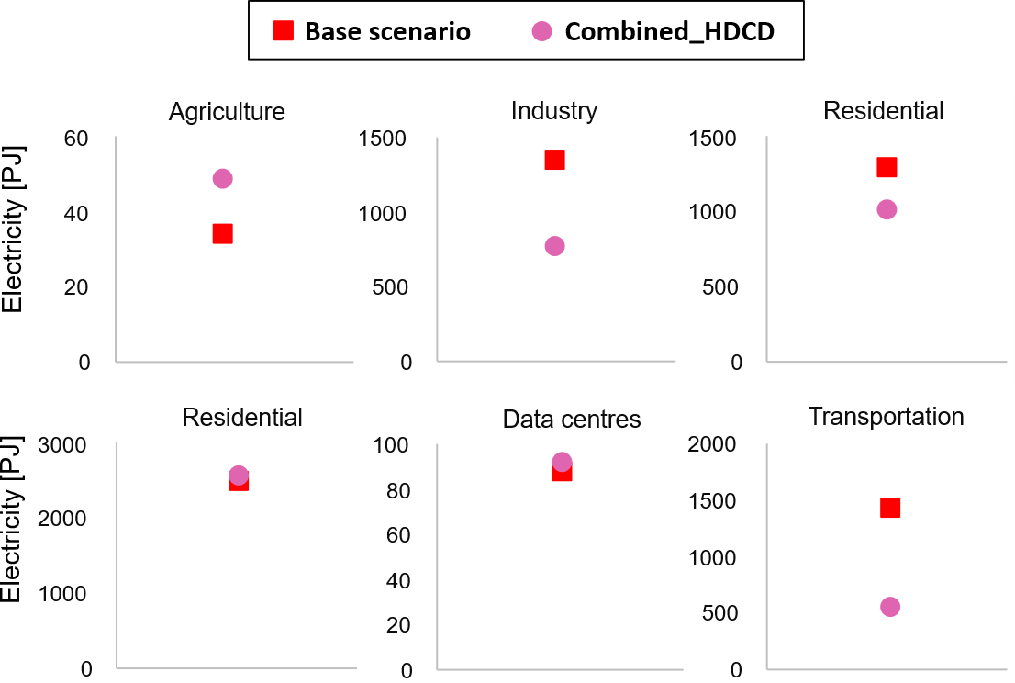
Figure S2. Total electricity delivered to different economic sectors in Ireland between 2026 and 2050 under the baseline and uncertainty scenarios. Red squares indicate the baseline scenario values, while pink circles are calculated using the median values across the uncertainty scenarios within the Combined_HDCD category.

Figure S3 highlights the impacts of geopolitical and supply-chain disruptions on Ireland’s energy trade balance and external energy dependencies.

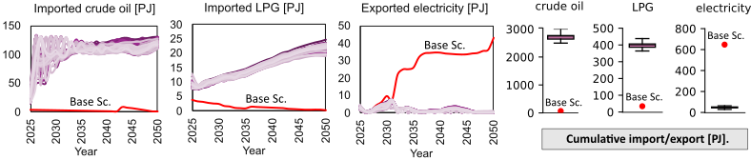
Figure S3. Variations in imports and exports of energy commodities across the uncertainty scenarios within the Combined_HDCD category. Pink shaded lines represent the range of uncertainty scenarios, while the red line corresponds to the baseline scenario. The panels on the right-hand side show the cumulative import and export values over the study period.
Figure S4 serves as a complement to Figure 6 in the main manuscript. It presents variations in power generation and transportation options due to mineral shortages for minerals with relatively smaller impacts.

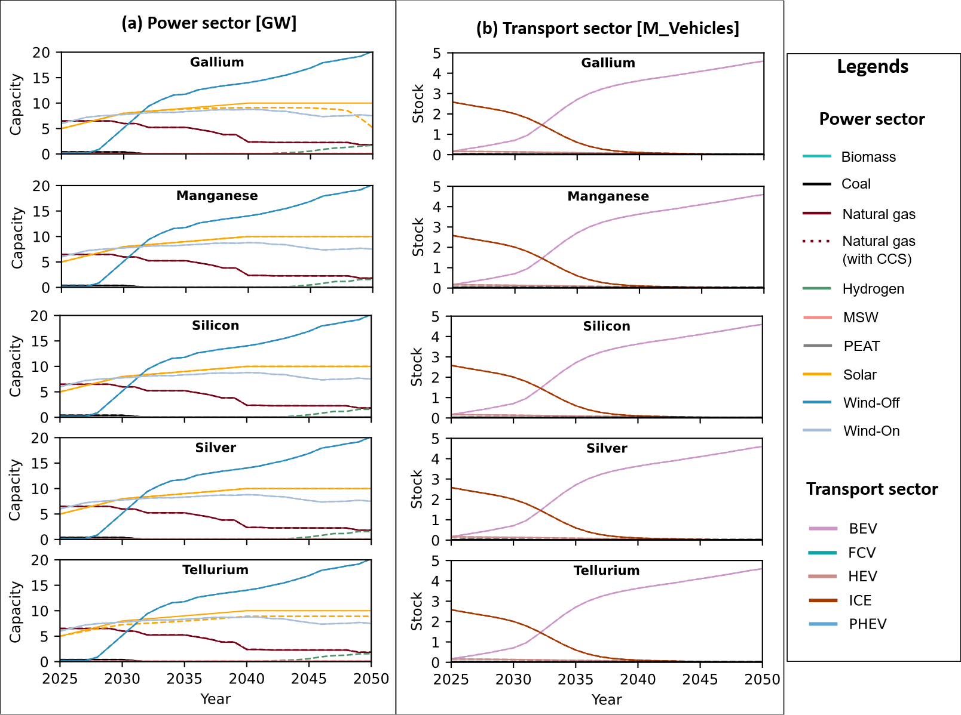
Figure S5. Evolution of power generation and transport technology capacities under individual critical mineral supply disruption scenarios. In each panel, solid lines represent the base scenario, and dashed lines show the corresponding mineral disruption scenario.

Section C: References
[1] SEAI, Energy price trends, Understanding the factors that affect energy prices is important for Ireland. It helps businesses, householders and policymakers to respond appropriately, 2025, https://www.seai.ie/data-and-insights/seai-statistics/prices, 2 Mar. 2026.
[2] Mac Domhnaill, C., Ryan, L., and Lazarczyk, E., When markets merge: evidence from Ireland’s integration with the European wholesale electricity market , Dublin, Apr. 2025, https://www.ucd.ie/economics/t4media/WP2025_10.pdf?utm_source, 4 Mar. 2026.
[3] TRADING ECONOMICS , Mar. 2026, https://tradingeconomics.com/commodity/crude-oil, accessed 30 Mar. 2026.
[4] Ireland Inflation Rate, TRADING ECONOMICS , Mar. 2026, https://fa.tradingeconomics.com/ireland/inflation-cpi, accessed 5 Mar. 2026.
[5] IEA (2023), Critical Minerals Market Review 2023, Jul. 2023, https://www.iea.org/reports/critical-minerals-market-review-2023, accessed 5 Mar. 2026.
[6] IEA (2025), Global Critical Minerals Outlook 2025, May 2025, https://www.iea.org/reports/global-critical-minerals-outlook-2025, accessed 5 Mar. 2026.
[7] BloombergNEF, Electric Vehicle Outlook 2025, 2025, https://about.bnef.com/insights/clean-transport/electric-vehicle-outlook/#download-report-summary, accessed 6 Mar. 2026.
[8] IEA (2025), Global EV Outlook 2025, Paris, 2025, https://www.iea.org/reports/global-ev-outlook-2025, accessed 6 Mar. 2026.
[9] Mulabdic, A. and V. Yotov, Y., Geopolitical Risks and Trade, 2025, https://papers.ssrn.com/sol3/papers.cfm?abstract_id=5778714, accessed 5 Mar. 2026.
[10] IEA (2026), Oil Market Report - March 2026, IEA, 2026, https://www.iea.org/reports/oil-market-report-march-2026, accessed 3 Apr. 2026.
[11] IEA, Critical Minerals Data Explorer, Paris, May 2025, Available at: https://www.iea.org/data-and-statistics/data-tools/critical-minerals-data-explorer, accessed 16 Jan. 2026.
[12] LePan, N., Visualizing the Size of Mine Tailings, Elements, May 2021, https://elements.visualcapitalist.com/visualizing-the-size-of-mine-tailings/, 12 Nov. 2023.
[13] REUTERS, China export curbs choke off shipments of gallium, germanium for second month, REUTERS, Oct. 2023,https://www.reuters.com/world/china/china-export-curbs-choke-off-shipments-gallium-germanium-second-month-2023-10-20/#:~:text=In%20July%2C%20China%20unveiled%20restrictions,in%20making%20high%2Dtech%20microchips., accessed 1 Mar. 2024.

